**Module Function Configuration** **List**

|  |  |  |  |
| --- | --- | --- | --- |
| **Cmd No.** | **Function** | **GPIO1 Behavior** | **Notes** |
| 0x00 | Standard Mode | Blank |  |
| 0x02 | Auto inventory tags. Wiegand 34 output(in-phase) | High Level On | Only support 1 Ant  Last 4 byte of EPC. |
| 0x03 | Auto inventory tags. Wiegand 26 output(in-phase). | High Level On | Only support 1 Ant  Last 3 byte of EPC. |
| 0x04 | Auto inventory tags，fast switch antenna mode. | High Level On |  |
| 0x05 | Auto inventory tags for a period of time after GPIO1 be triggered once, fast switch antenna mode.（Time can be set） | High Level On | Set trigger time by set Switch Interval between antennas, Note: unit is Sec. |
| 0x06 | Auto inventory tags. Wiegand 26 output (reversed-phase). | High Level On | Only support 1 Ant |
| 0x09 | Auto inventory tags, fast switch antenna mode.  Wiegand 26 output(in-phase). | High Level On | Suit for M-500: auto inventory tags |
| 0x0A | Auto inventory tags, fast switch antenna mode.  Wiegand 26 fast output(in-phase, time between Wiegand datas is 5mS). | High Level On |  |
| 0x0B | Auto inventory 6B tags. Wiegand 26 output(in-phase). | High Level On |  |
| 0x0C | Auto inventory 6B tags. Wiegand 26 output(reversed-phase). | High Level On |  |
| 0x0F | Auto inventory tags, fast switch antenna mode. | Low level On |  |
| 0x10 | Auto inventory tags, fast switch antenna mode. Can get buffer. | High Level On |  |
| 0x11 | Auto inventory tags, fast switch antenna mode. Reading Identifier of Reader at the same time. | High Level On | Intervals due to quantity of tags. |
| 0x12 | Auto inventory tags, fast switch antenna mode. Every times read tag will trigger GPIO3 output (High). | High Level On | Set trigger time by set Switch Interval between antennas, Note: unit is Sec. |
| 0x13 | Auto inventory tags. | Low level On | Low power consumption mode.  Only support 1 Ant |
| 0x18 | Auto inventory tags, fast switch antenna mode. | High Level On | Only suit for 8 port module |

Note：1. **GPIO1 Behavior** is just suit for Module Series;

2. Evaluation Board please see *R2000 Evaluation Board User Manual* ->*2.6.1 Set GPIO Level;*

3. S-8600/8800 4/8-Port Reader please see *s8600/8800 user manual*->*2.6.3 Set GPIO Level.*

4. Please do not send other Cmd to module frequency when module is auto working mode.

Regarding 8 Port Module pls see : **2. Setting by Cmd.**

1. Setting by software

1.1 Setting Function Configuration

Launch the supplied Software: **Function_ID.exe**, the following screen displays:

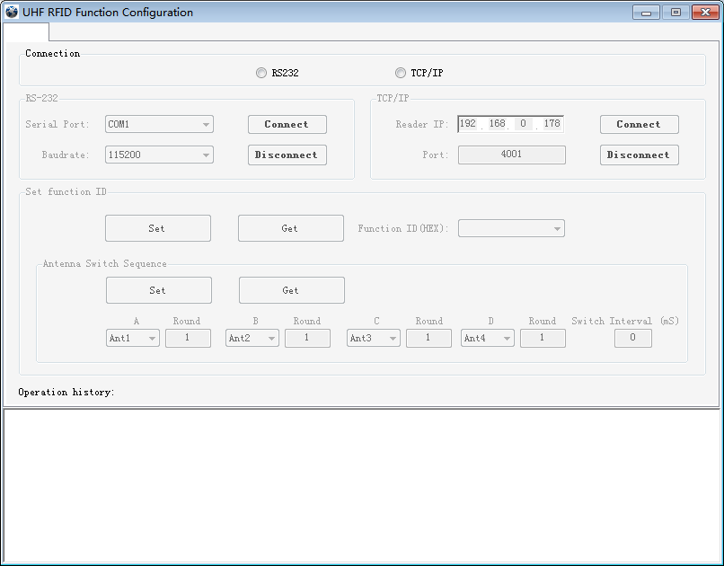

Connecting **Reader** with **UHF RFID Function Configuration**. Selecting the corresponding **Function ID**:

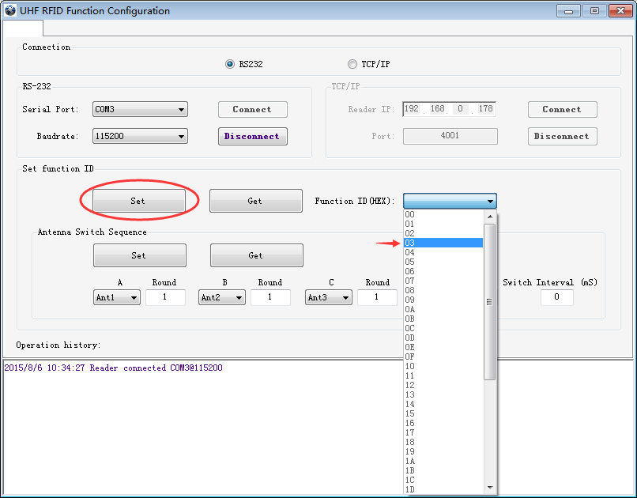

Click **Set**, the **Operation history** column displays:

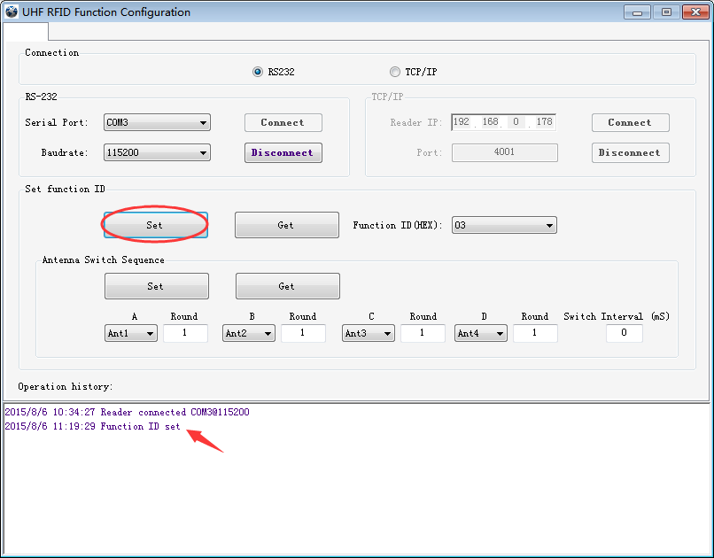

Now, **Function Configuration** has been set successfully. Reader will work as the corresponding Function Mode.

Users also can click **Get** to check the Reader working mode:

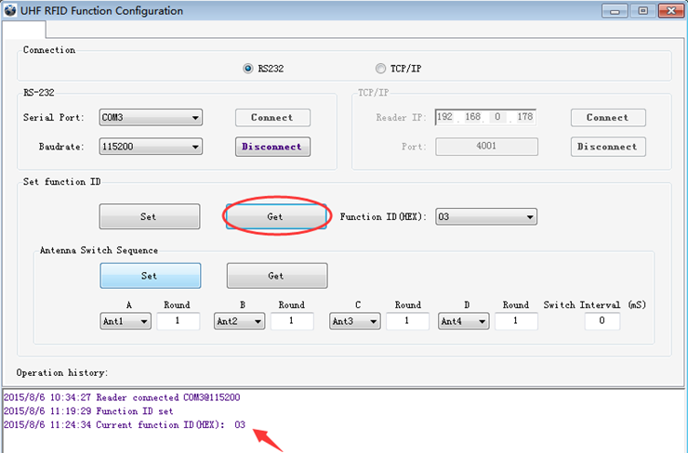

1.2 Setting Antenna Switch Sequence

For example: Setting antenna Switch Sequence under 04 mode, using Ant 1 only.

First step: Set 04 mode.

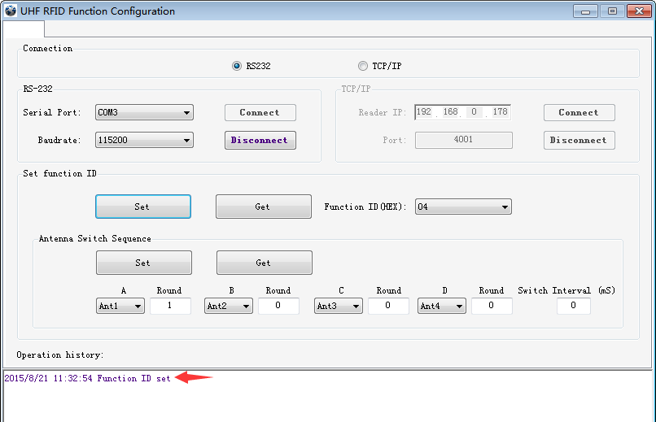

Second step: set Ant2, Ant3, Ant4 Round times to 0, click **Set:**

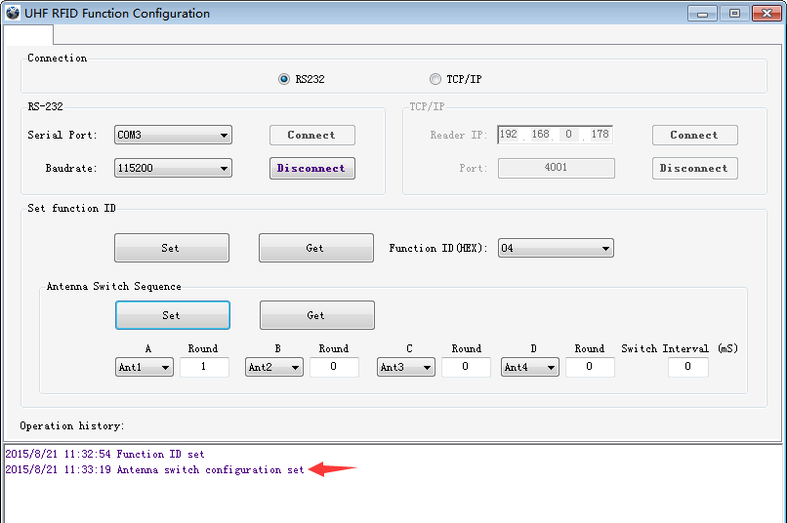

Then click **Get**, the follow screen as below means set **Antenna Switch Sequence** successfully:

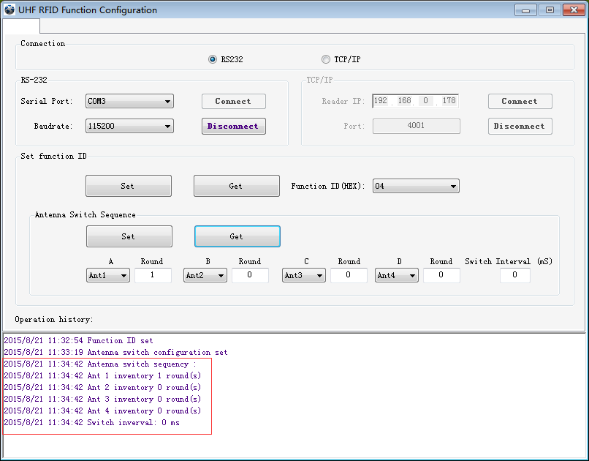

1. Setting by Cmd.

2.1 Setting Function Configuration

Host packet:

|  |  |  |  |  |
| --- | --- | --- | --- | --- |
| **Head** | **Len** | **Address** | **Cmd** | **Check** |
| 0xA0 | 0x04 |  | 0xA0 |  |

**◆Succeeded:**

Response packet:

|  |  |  |  |  |  |
| --- | --- | --- | --- | --- | --- |
| **Head** | **Len** | **Address** | **Cmd** | **ErrorCode** | **Check** |
| 0xA0 | 0x04 |  | 0xA0 | CommandSuccess |  |

eg：Standard Mode: **A0 04 FF A0 00 BD**

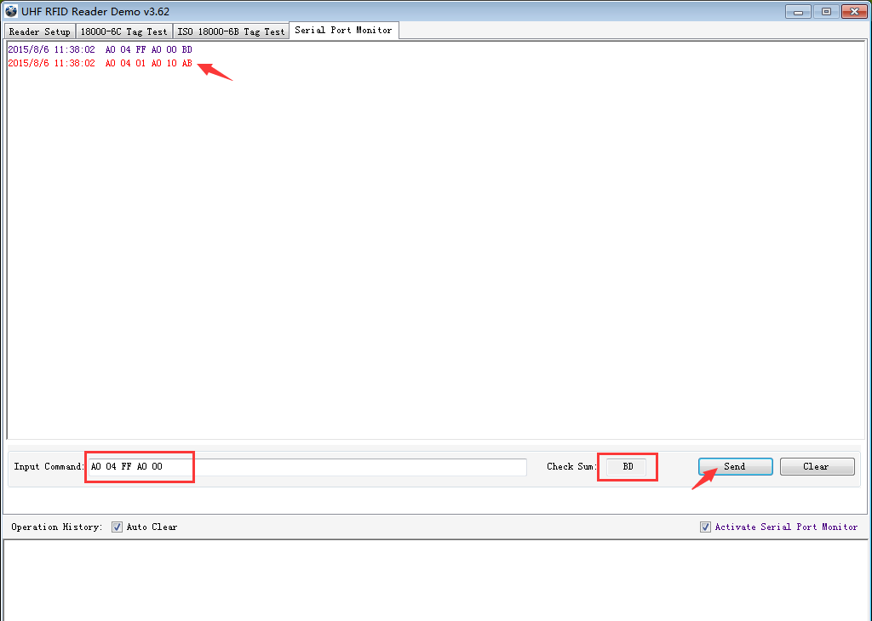

**Note**: About **Check** please see *UHF RFID Reader Serial Interface Protocol V3.1.*.

Then, Reader will work as the corresponding Function Mode.

2.2 Setting Antenna Switch Sequence

Cmd of Setting Antenna Switch Sequence is **cmd_fast_switch_ant_inventory**:

Host packet:

|  |  |  |  |  |  |  |  |  |  |  |  |  |  |  |
| --- | --- | --- | --- | --- | --- | --- | --- | --- | --- | --- | --- | --- | --- | --- |
| **Head** | **Len** | **Address** | **Cmd** | **A** | **Stay** | **B** | **Stay** | **C** | **Stay** | **D** | **Stay** | **Interval** | **Repeat** | **Check** |
| 0xA0 | 0x0D |  | 0x8A |  |  |  |  |  |  |  |  |  |  |  |
|  | | | | | | | | | | | | | | |
| Parameter Description | A | | | First working ant (00 – 03). If set this byte above 03 means ignore it. | | | | | | | | | | |
| Stay | | | Inventory round for an antenna. Every antenna has this parameter. | | | | | | | | | | |
| B | | | Second working ant (00 – 03). If set this byte above 03 means ignore it. | | | | | | | | | | |
| C | | | Third working ant (00 – 03). If set this byte above 03 means ignore it. | | | | | | | | | | |
| D | | | Fourth working ant (00 – 03). If set this byte above 03 means ignore it. | | | | | | | | | | |
| Interval | | | Rest time between switching antennas. During the cause of rest, RF output will be cancelled, thus power consumption and heat generation are both reduced. | | | | | | | | | | |
| Repeat | | | Repeat the inventory with above ant switch sequence. | | | | | | | | | | |

For example: Setting antenna Switch Sequence under 04 mode, using Ant 1 only.

1. First step, set 04 mode, send cmd: **A0 04 FF A0 04 B9**
2. Second step, send cmd: **A0 0D FF 8A 00 01 01 00 02 00 03 00 00 01 C2**

Then, Ant1 of module will auto working under 04 mode.

Note：8 Port Module pls see *M-2900 Communication Interface Specification*